DEVOPS PBL

PRN- 2124UDSM1013

NAME- SADAPHAL PRANIT BHAUSAHEB

SET 4

Q1. (15 Marks)

Create a new Git repository locally, add a Java file (HelloWorld.java), commit it, and push it to

your GitHub repository.

Expected Output: Code and commit visible on GitHub.

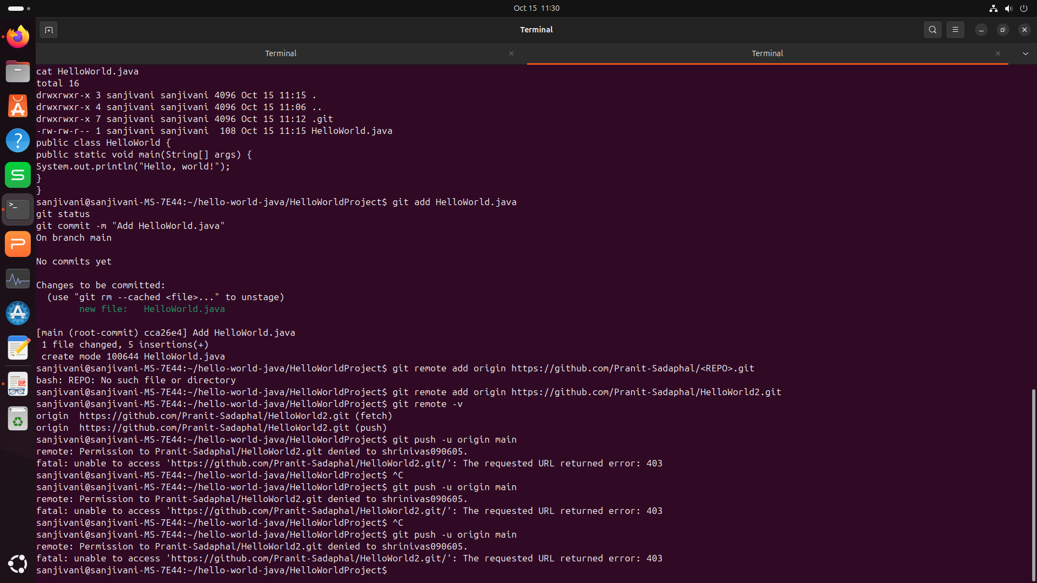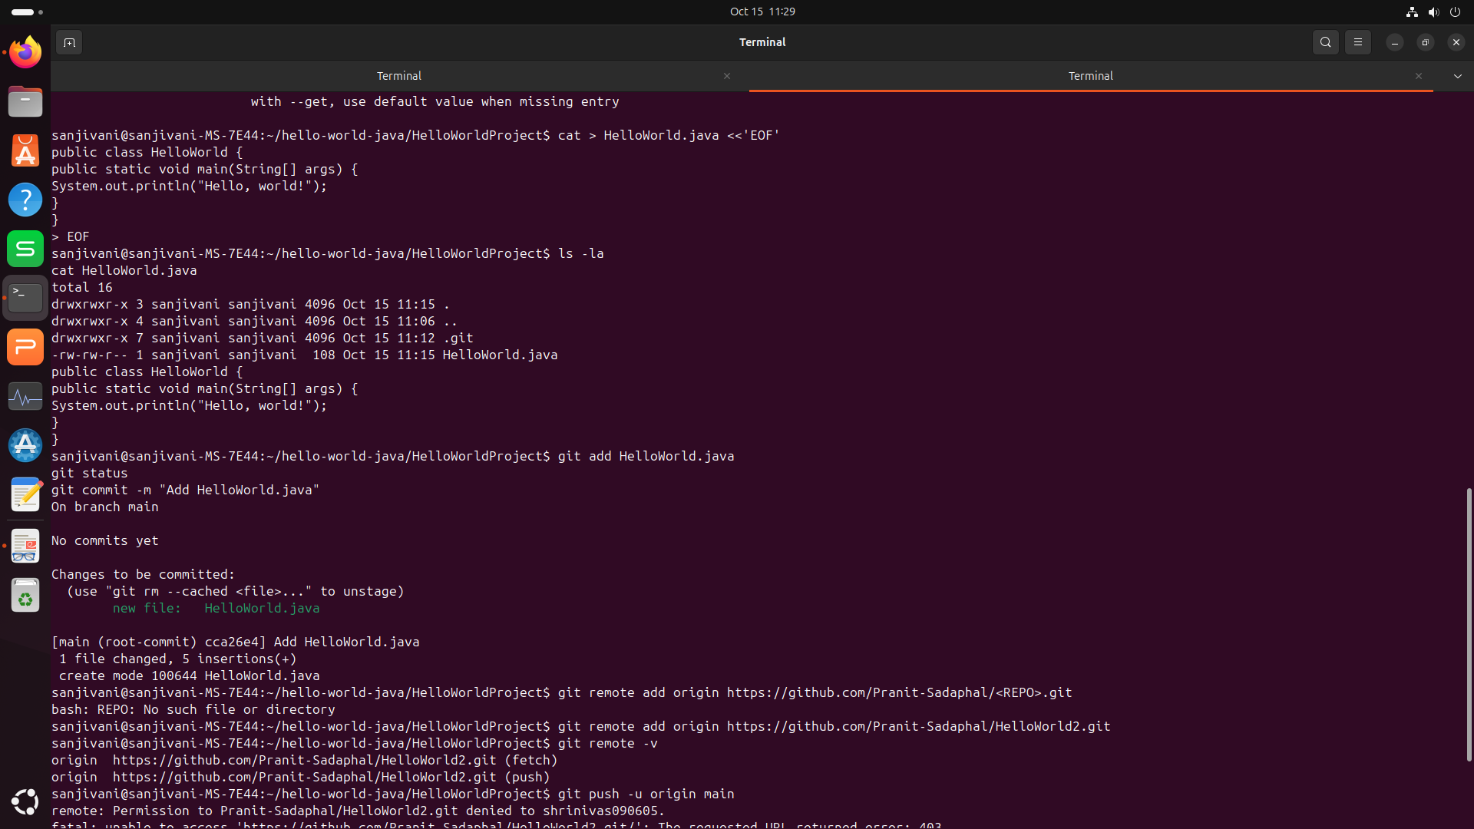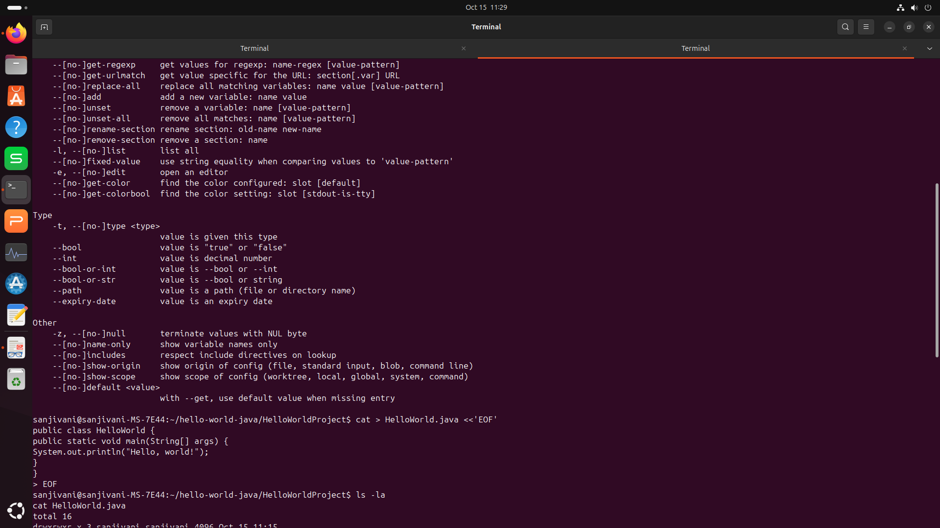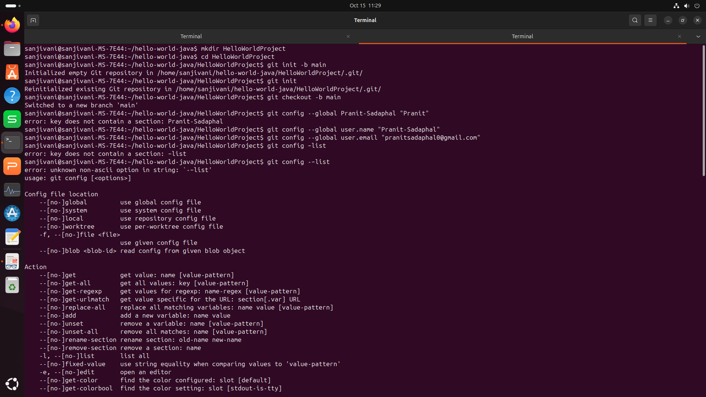

OUTPUT

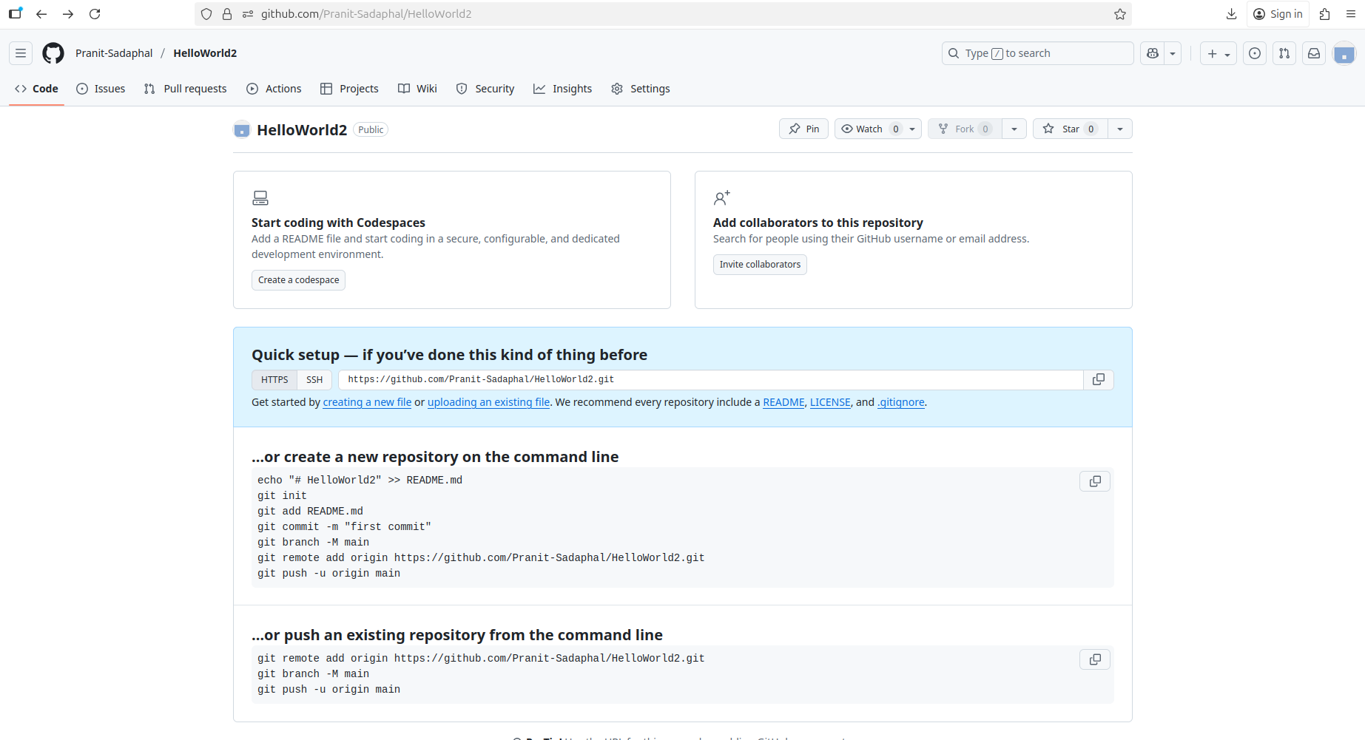

Q2. (15 Marks)

Create a simple Maven project using the command line and build it using mvn clean

package.

Expected Output: Successful build with .jar file in target folder.

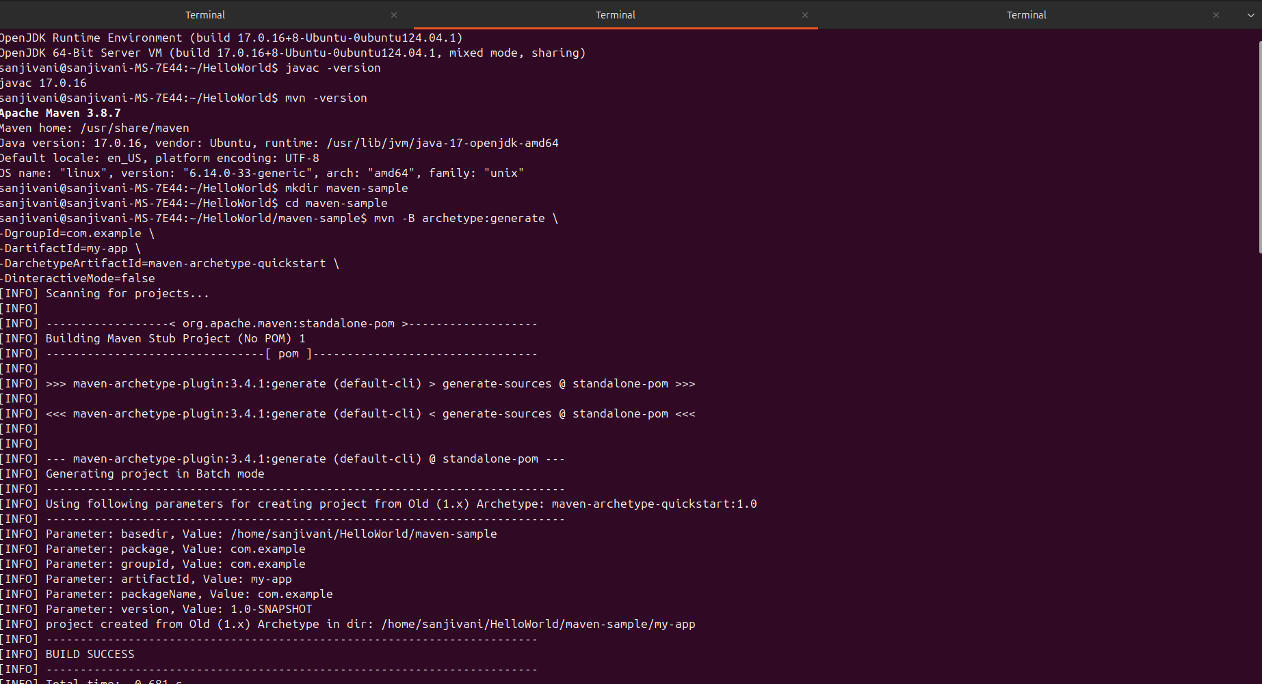

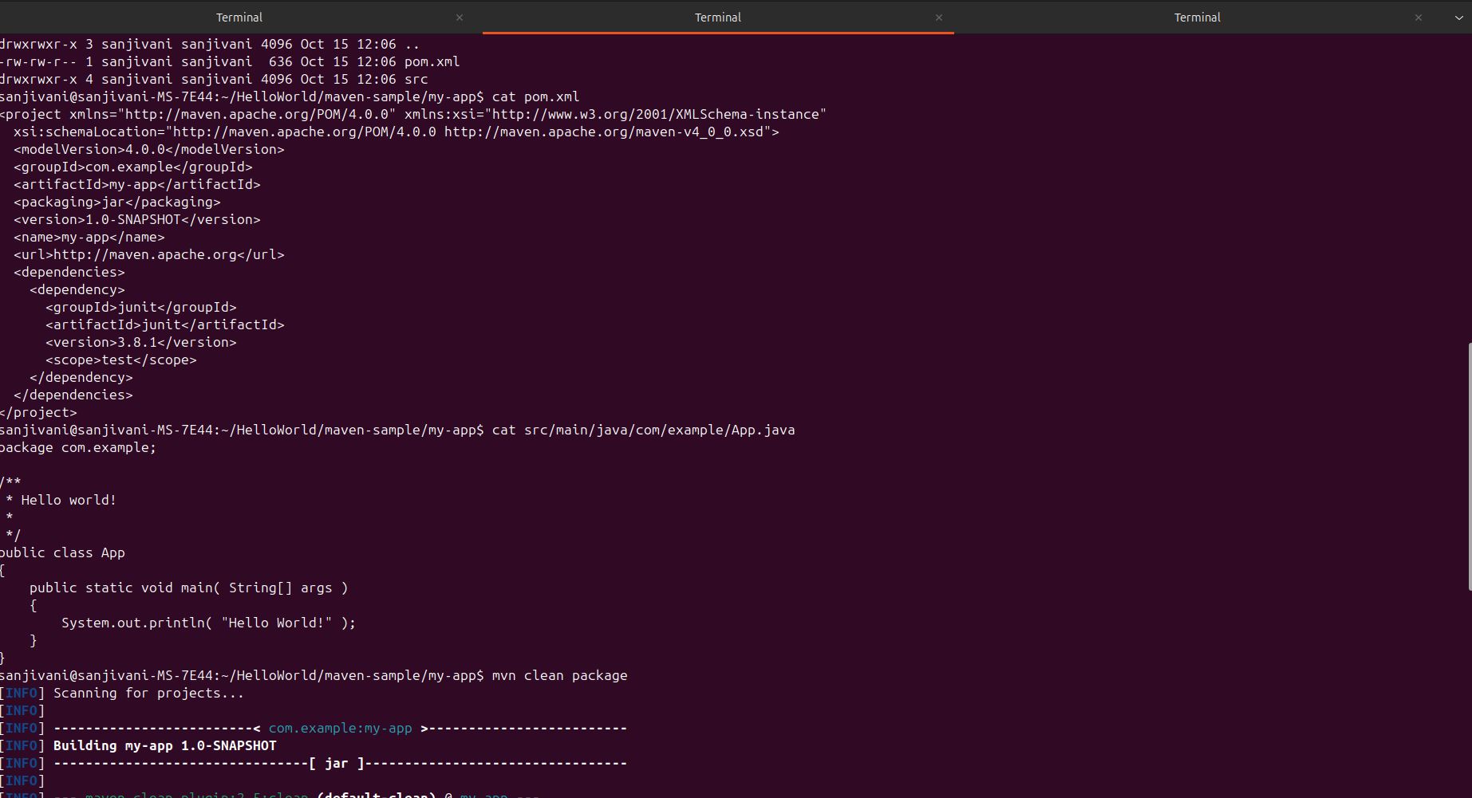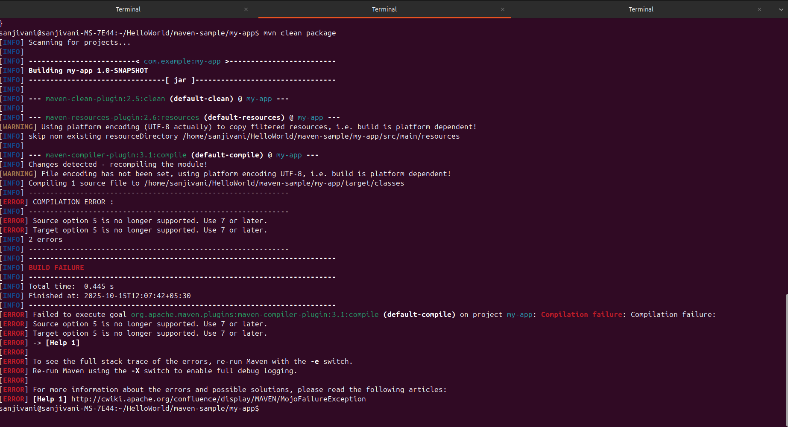

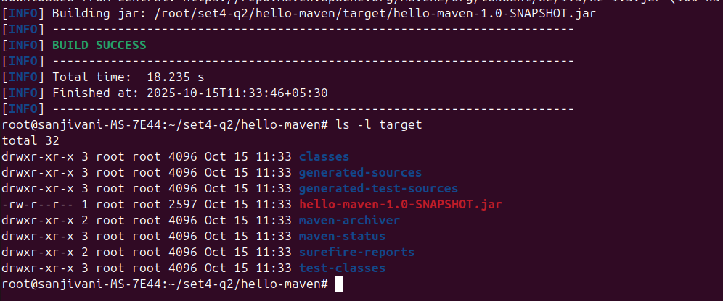

Q3. (10 Marks)

Create a Dockerfile for your Maven project and build a Docker image using the command

line.

Expected Output: Docker image visible in docker images.

